1 - Create a program that prints a random integer between 1 and 100

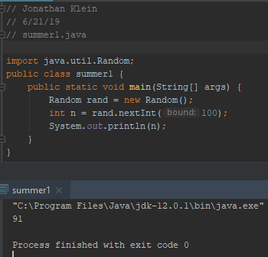

2 - Create a program that finds the square of a given integer variable

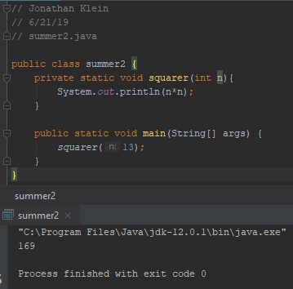

3 - Create a program that capitalizes a provided String variable

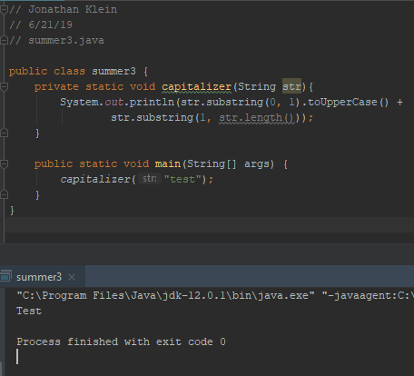

4 - Create a program that detects if a String contains the word “Java”, and provide at least three variables for testing

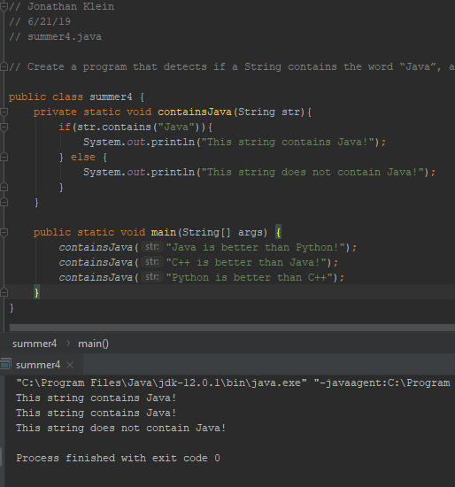

5 - Create a program that prints the first two letters of a provided String variable

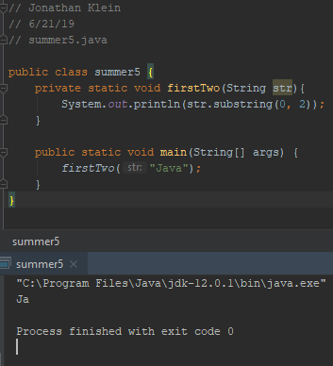

6 - helloName

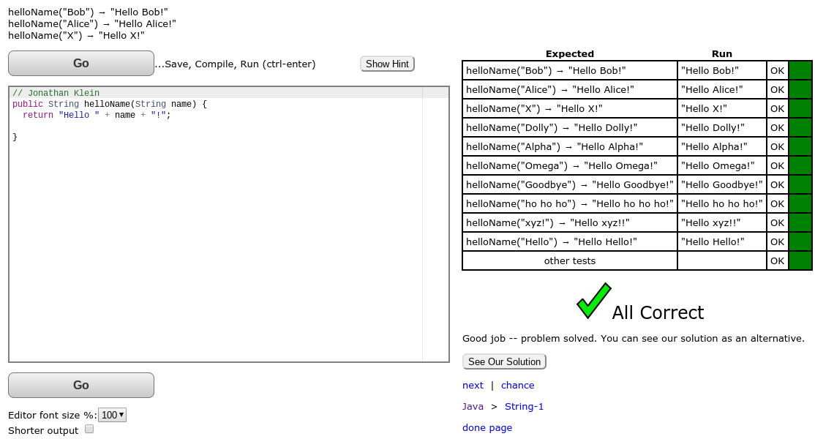

7 - makeTags

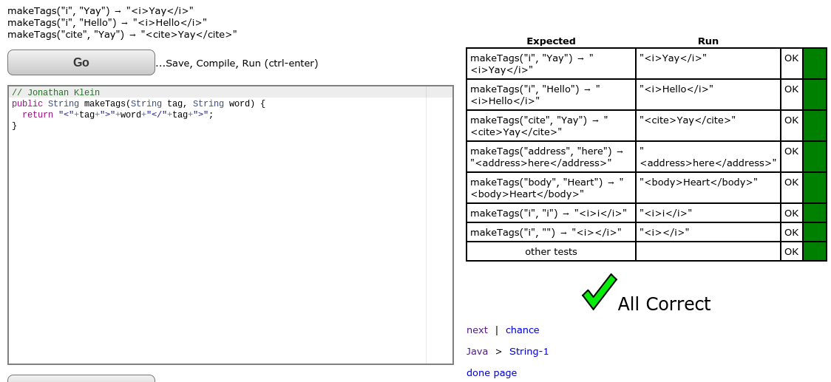

8 - makeOutWord

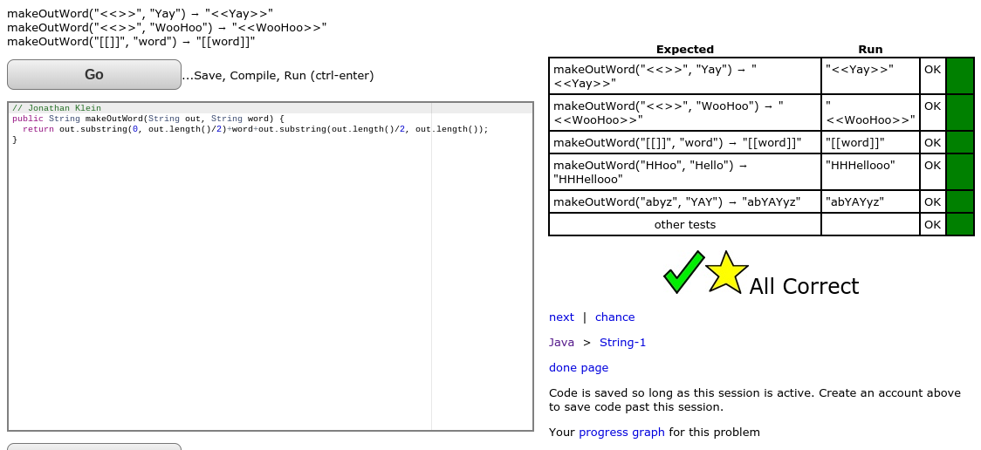

9 - cigarParty

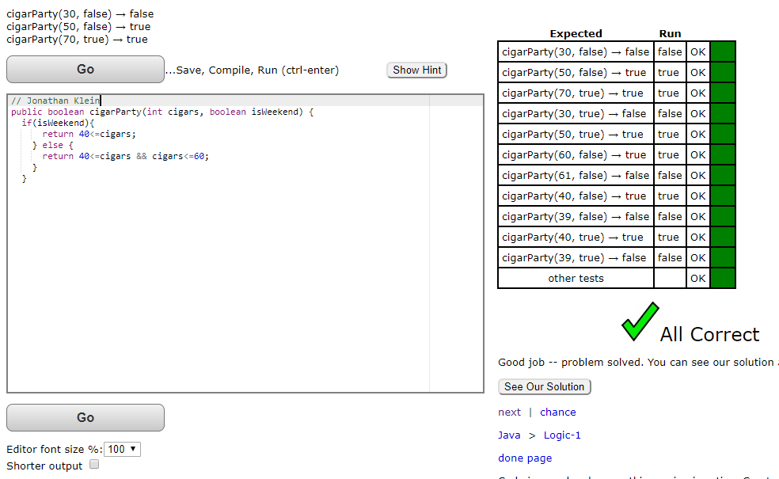

10 - dateFashion

